Solution Architecture
Date | 10 July 2026
Team ID | AIML-HDI-2026
Project Name | A Comprehensive Measure of Well-Being
Maximum Marks | 5 Marks

Solution Architecture Diagram
A high-level visual representation of the solution's architecture, mapping the Presentation Layer, Application Layer, and Data Layer for the HDI Intelligence Engine.
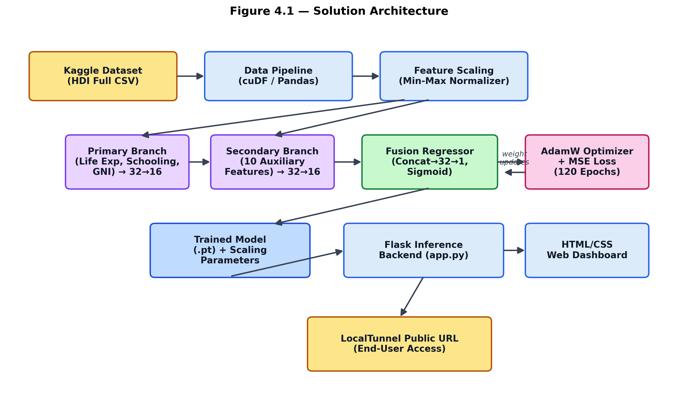
Figure: End-to-end solution architecture, from Kaggle dataset ingestion to the deployed web dashboard.

Component Description Table
Component Name | Description / Role in Architecture | Technologies Used
Presentation Layer | Provides the user interface for inputting socio-economic indicator values and displaying the forecasted HDI results. | HTML5, CSS3, Jinja2
API Gateway | Acts as the entry point for the application, routing user requests to the backend prediction logic. | Flask (Python), LocalTunnel
Core Logic Service | Handles feature scaling and executes the dual-branch hybrid neural network to perform the HDI calculation. | PyTorch (EnhancedHybridHDINet)
Database / Storage | Stores the trained model weights and Min-Max scaling parameters, and processes incoming user data requests. | PyTorch serialization (torch.save)

